**Project Report**

**E-commerce Website using Laravel and mysql**



**Spring 2023**

**Database Management System**

**Submitted by:**

**Maaz Habib{20PWCSE1952}**

**Hamid Ur Rehman{20PWCSE1969}**

**Danyal Khursheed{20PWCSE1959}**

“On my honor, as student of University of Engineering and Technology, I have neither given nor received unauthorized assistance on this academic work.”

Student Signature: ______________

Submitted to:

Ma’am Sumayyea Salahuddin

Thursday, July 7th, 2023

**Department of Computer Systems Engineering**

**University of Engineering and Technology, Peshawar**

**Introduction:**

An online storefront known as an ecommerce website enables companies to conduct online sales of goods and services. Customers may effortlessly browse, choose, and buy things from this virtual storefront at any time and from any location. E-commerce has revolutionized business operations by allowing companies to contact a worldwide clientele and complete transactions online.

Due to its multiple benefits for both customers and businesses, the idea of ecommerce has been very popular in recent years. An e-commerce website gives companies the chance to increase their customer base outside physical stores, cut expenses, and offer specialized shopping experiences. It enables companies to exhibit their goods or services, offer thorough descriptions, high-quality photos, and client testimonials, as well as securely take a range of payment options.

However, e-commerce offers users accessibility and convenience that are unmatched. Customers can quickly search for products, compare prices, read reviews, and make purchases on an e-commerce website without ever leaving their homes. It saves time and effort by providing a seamless and user-friendly purchasing experience. To further improve the overall buying experience, ecommerce frequently offers tools like personalized suggestions, order monitoring, and customer care.

Key characteristics of e-commerce websites include:

* **Product Catalogue:** A thorough listing of goods and services for sale, with thorough descriptions, technical details, and pictures.
* **Shopping Cart:** Customers can add products to their virtual shopping cart, view their selections, change the quantity of each item, and then check out.
* **Secure Payment Processing:** Integrating with reputable payment gateways to provide safe online transactions while enabling a range of payment options (such as credit cards and digital wallets).
* **Order Management:** Order management tools include order tracking, invoicing, and shipping information. They are used to manage and process customer orders.
* **User Accounts:** Users can create accounts, maintain their profiles, check order histories, and remember preferences through the user registration and login capabilities.
* **Search:** Customers may identify certain products more quickly with the help of robust search capability and filtering choices.
* **Customer Reviews and Ratings:** A system that allows customers to comment on, rate, and review goods and services in order to help other customers make wise purchases.
* **Discounts and promotions:** Tools for using promo codes, launching marketing campaigns, and promoting exclusive deals to draw in and keep clients.

**Conceptual schema of ecommerce website: (lab 8)**

**Entities:**

* **User:**

Represents a registered user of the ecommerce website. Attributes: UserID (unique identifier), Username, Email, Email verified, City, Address1, Address2,Pincode, State, Country Mnumber, Altnumber, password, status, role, remaining token, created_at, updated_at Phone, etc.

* **Password Reset:**

Represents a password reset request made by a user. Attributes: Email, Token, created_at .

* **Newsletter Subscription:**

Represents a user's subscription to the website's newsletter. Attributes: SNo, UserID, created_at, updated_at, name, email.

* **Transaction:**

Represents a transaction or activity performed by a user on the website. Attributes: TransactionID (unique identifier),TXNID, order,email, status, amount, created_at, updated_at.

* **Order:**

Represents an order placed by a user. Attributes: OrderID (unique identifier), Customer_Email,Delivery_Address, Order_Detail, Coupen_code, Amount, paymentmode, Shipping_Status, Order_cancel_status, Shippping_staus, Delievey_status, Order_Cancelation_on, p_status, p_status_updated, created_at, Updated_at etc.

* **Product:**

Represents a product available for purchase on the website. Attributes: ProductID (unique identifier), Name, Description, Priority , Img1, img2 , keyword meta_description , status Price, StockQuantity, etc.

* **Migration:**

Represents data migration activities for the ecommerce website. Attributes: MigrationID (unique identifier), Migration, Batch etc.

* **Coupon:**

Represents a discount coupon that users can apply during checkout. Attributes: CouponID (unique identifier), Code, vaidform, validupto, discount, created_at, updated_at, etc.

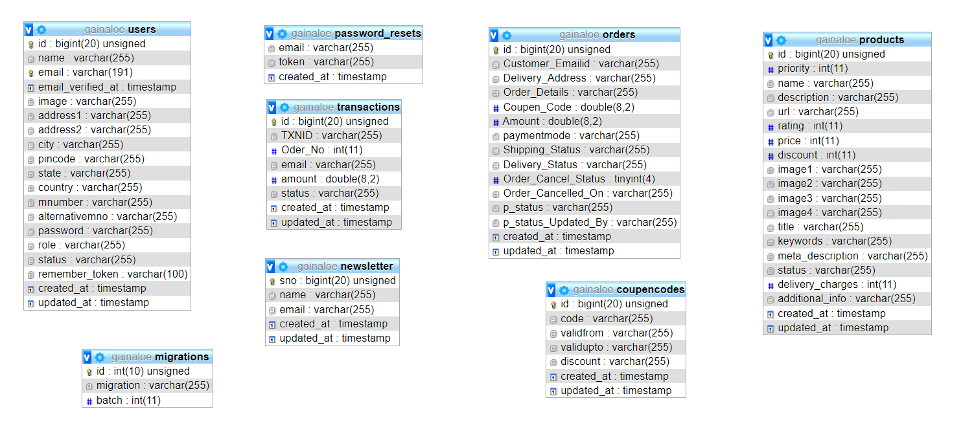

There is no foreign key in the project we have connected all the tables custom.

**Database Overview: ( lab 9 )**

First of all we see database tables and then we will exam each one by one.

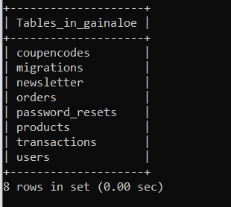

* **User:**

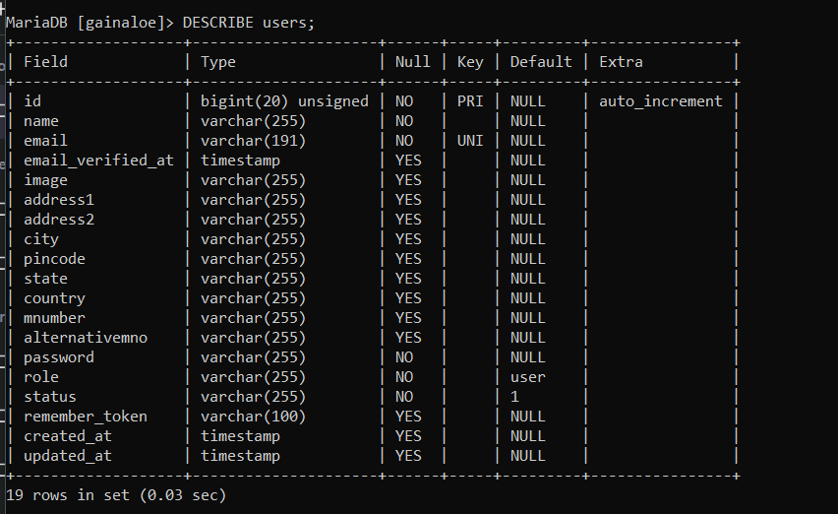

* **Transaction:**

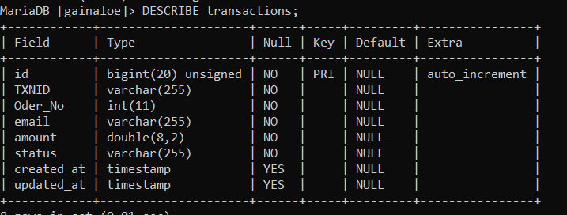

* **Product:**

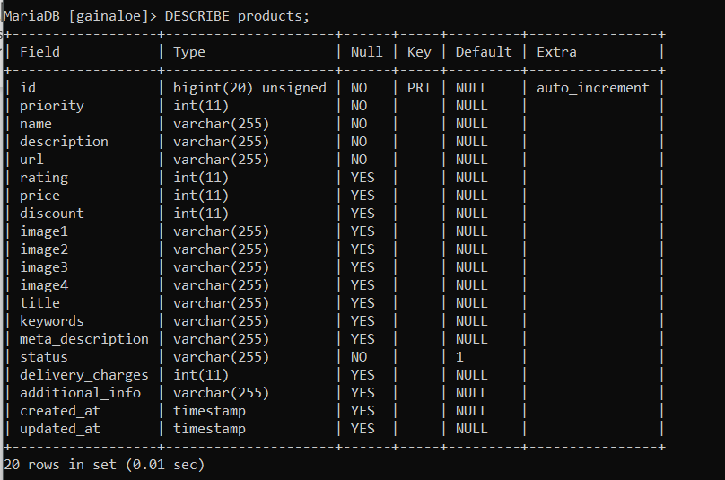

* **Password Reset:**

* **Order:**

* **Newsletter Subscription:**

* **Migration**

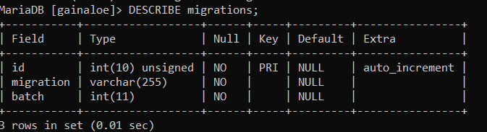

* **CoupenCode:**

**Project Display: (lab 10)**

**Home Page:**

This page contain slider products box , contact info , and clients review,

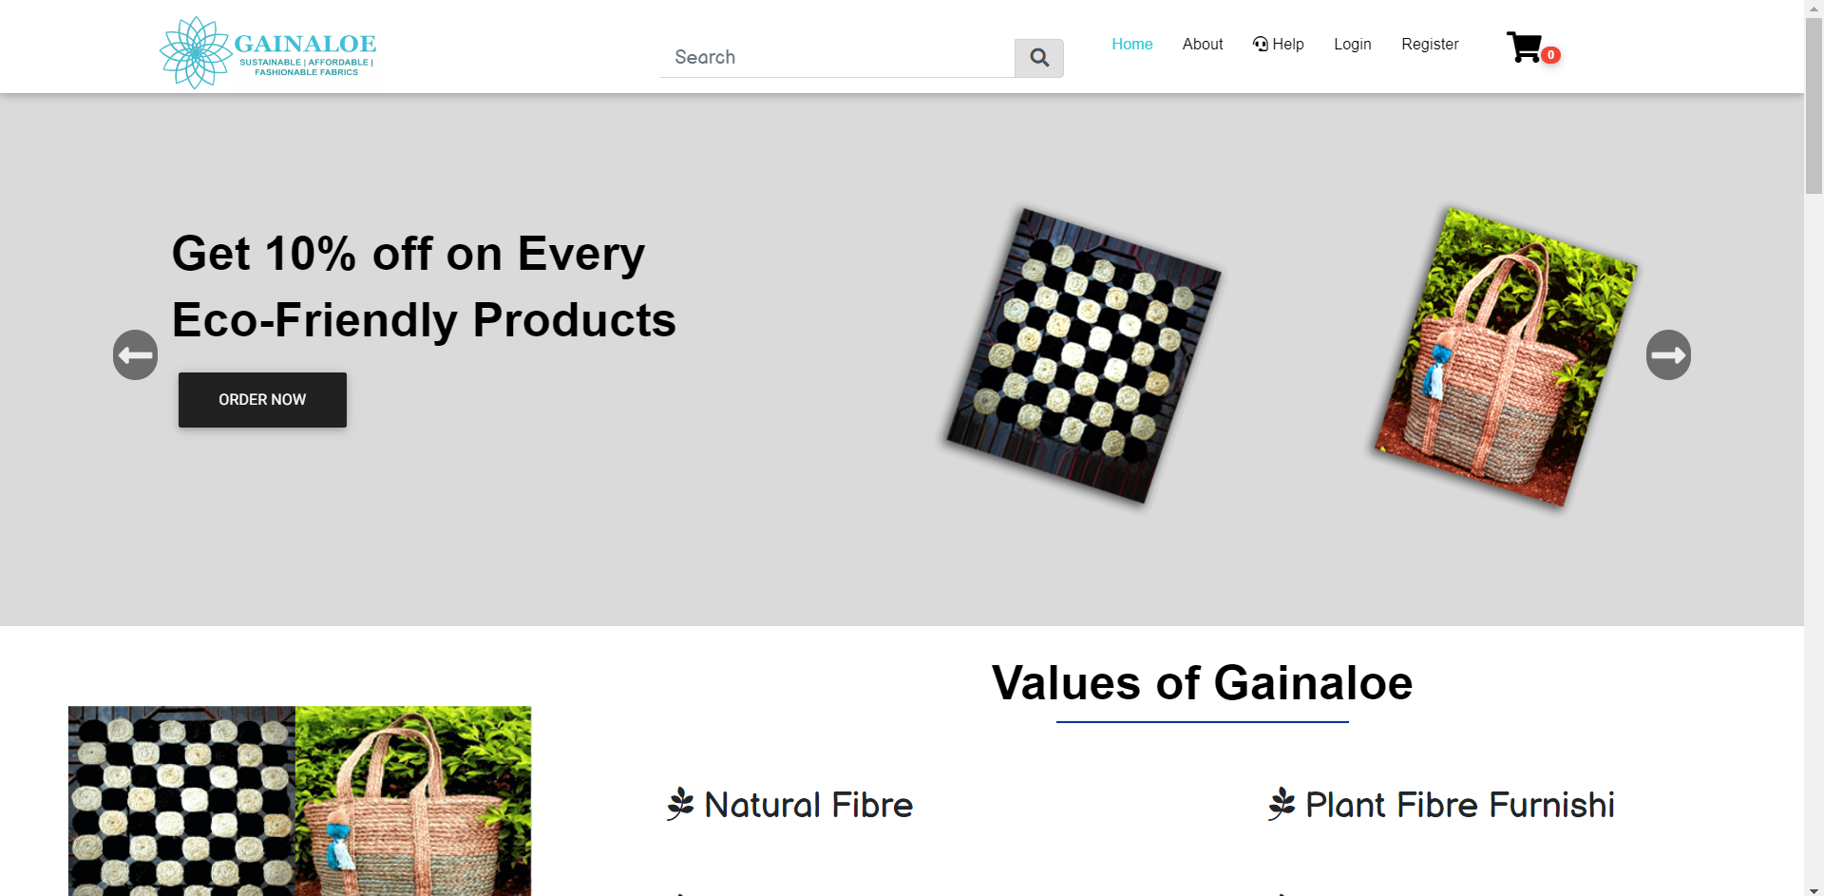

**Products:**

**Contact:**

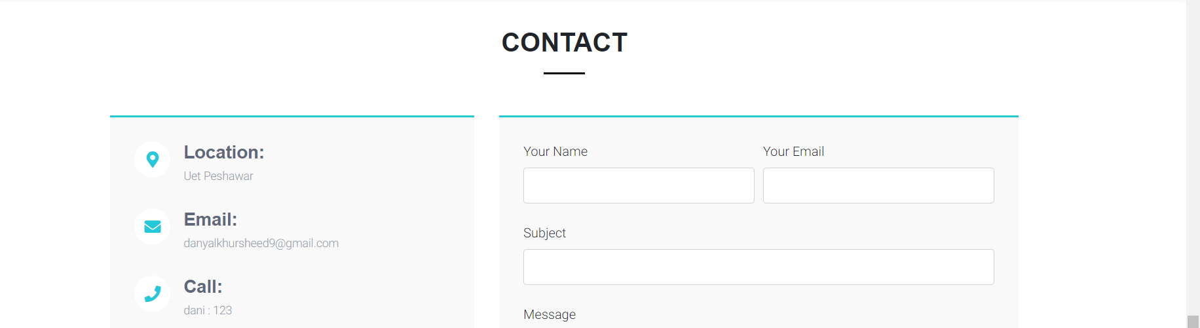

**Products detail:  
**

**Cart:**

**Shipping detail:**

**Order Confirmation:**

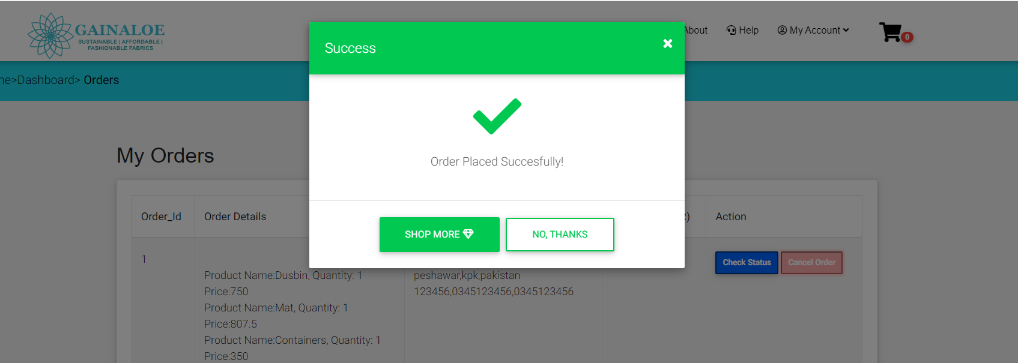

**Admin Panel:**

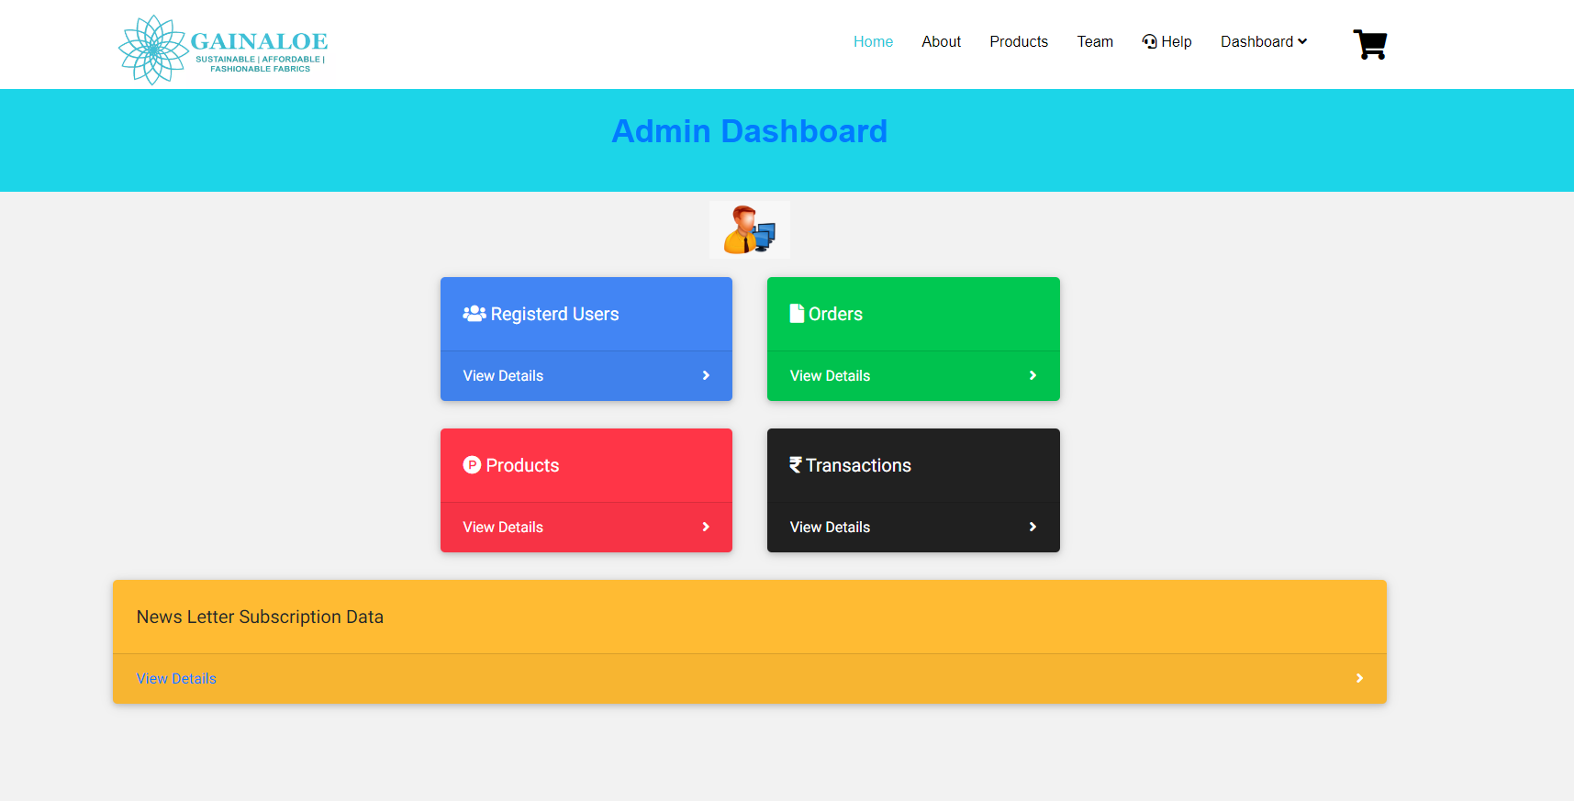

**User:**

**Orders**

**Products:**

We can add new products and remove it as well

